Project Report

1. Aims

* Create a Draughts Game
* Two player game (local)
* Allow for both normal pieces and king pieces with their corresponding move sets
* Allow player to save current game and load game later
* Display outcome of game

1. Analysis

I will use Pygame so that I can use its functions to create the game board and allow the players to interact with it.

As the game is going to be for two players playing at the same computer, I will need to use an input method which allows each player to select a move while also following the turn structure. This will have to prevent players from making multiple moves or moves when it is not their turn.

Normal pieces and king pieces will be in play so the program needs to be able to differentiate between the types of pieces the players select as well as their colour. The two different types of piece will have their own move sets as well as be visually distinct from one another.

The program will need a way to determine if a player wishes to save/load a game. This input method will be different than the one used by the players for move selection so that one input system doesn’t conflict with the other. When the game is saved, the turn structure must be preserved so that when the game is loaded again the correct player is allowed to move. Can be accomplished by using pickle.

When the game has been won by a player, the program will display the result of the game. The program will need to keep track of the number of pieces remaining for each colour and when either amount reaches 0.

1. Design

Class Diagram:

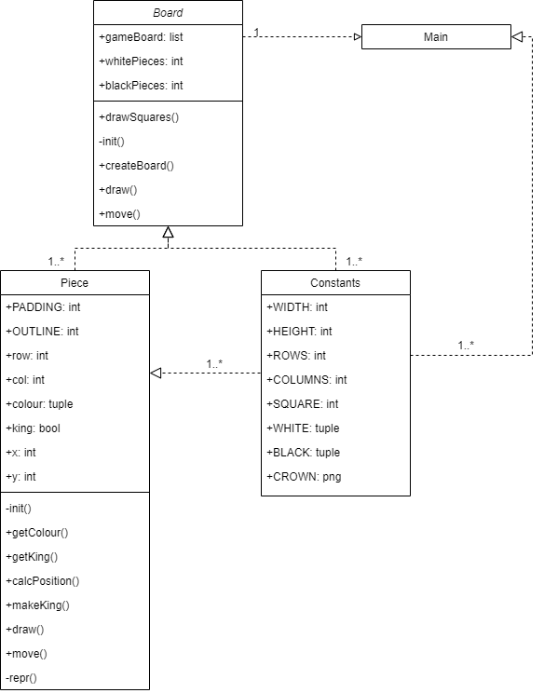

Move Flowchart:

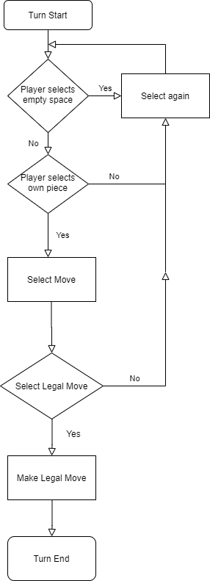

Take Piece Flowchart:

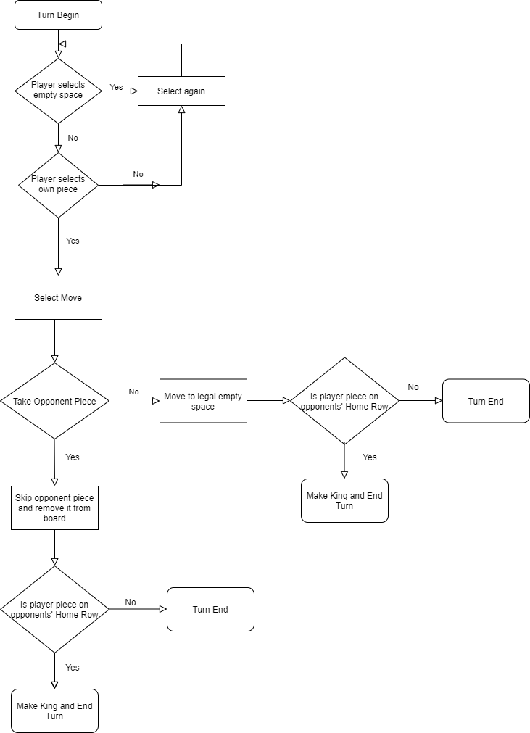

Game Over Flowchart:

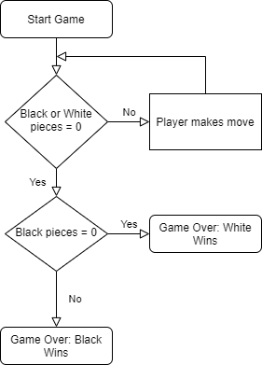

1. Testing

|  |  |  |  |  |  |
| --- | --- | --- | --- | --- | --- |
| Test Number | Test Type | Test Description | Expected Outcome | Actual Outcome | Pass/Fail |
| 1 | Valid | Try to move piece into a legal empty square | Move piece | Move piece | PASS |
| 2 | Invalid | Try to move piece into illegal empty square | Don’t move piece | Don’t move piece | PASS |
| 3 | Valid | Try to move in all 4 valid directions with a king piece | Move piece | Move piece | PASS |
| 4 | Valid | Try to take an opponent’s piece legally | Take piece and skip over opponent | Take piece and skip over opponent | PASS |
| 5 | Invalid | Try to take an opponent’s piece illegally | Don’t take piece | Don’t take piece | PASS |
| 6 | Valid | Try to take multiple pieces | Take piece and skip over opponent and repeat until it is not possible to take more pieces | Only takes one piece before ending the turn, no matter the situation | FAIL |
| 7 | Valid | Win a game as Black to see if results are displayed correctly | Displays that Black has won | Displays that Black has won | PASS |
| 8 | Valid | Win a game as White to see if results are displayed correctly | Displays that White has won | Displays that White has won | PASS |
| 9 | Valid | Save game, close and reopen game, load saved game | Opens the saved game with the turn order preserved | Opens the saved game with the turn order preserved | PASS |
| 10 | Valid | Save game, continue playing game, load saved game | Saves the game and allows players to continue playing. When loaded, previous version of current game is restored with correct turn order. | Saves the game and allows players to continue playing. When loaded, previous version of current game is restored with correct turn order. | PASS |
| 11 | Valid | Can player interact with game using the mouse | Registers player mouse clicks | Registers player mouse clicks | PASS |
| 12 | Valid | Can player interact with game using keyboard | Registers players keyboard inputs | Registers players keyboard inputs | PASS |

1. Critique

Positive:

* Save and load function work correctly
* Game has both king pieces and normal pieces with distinct visual difference
* Player turns work correctly
* Board and pieces display correctly
* Displays outcome of the game when a player wins
* Can only make legal moves (excluding taking multiple pieces)

Negative:

* Cannot take multiple pieces
* If a stalemate occurs, a results screen will not be printed, essentially freezing the game as no valid moves are possible
* No single player mode with AI
* Cannot save and load multiple different game instances
* Although turns work correctly, program does not display who’s turn it is
* You don’t have to take pieces if you can which is against the rules of Draughts

Improvements that could be made:

* Allow players to take multiple pieces
* If a stalemate occurs, output a message saying one has occurred, ending the game
* Allow player to pick whether they want to play against another human locally or alone against an AI opponent
* Allow multiple different games to be saved
* Display who’s turn it is
* Display valid moves for the selected piece
* Make it so player has to take piece/pieces if they can according to the rules of Draughts